- Chemical Product and Company Identification
Product Name | Suppleyes Auto Dishwashing Detergent
Product Code | 5lt: 20109
Product Use | Alkaline and chlorine mixture for automating dishwashing machines
Supplier | Suppleyes
ABN | 36 164 719 108
Mail Address | Unit 38/8 Distribution Court Arundel QLD 4214
Email | info@suppleyes.com.au
Telephone: | 07 55 949 452
Emergency Telephone: | Poisons Information Centre (National) 131126
- Hazards Identification
Statement of Hazardous Nature
This product is classified as: N, Dangerous to the environment. C, Corrosive. Hazardous according to the criteria of SWA.
Dangerous according to Australian Dangerous Goods (ADG) Code, IATA and IMDG/IMSBC criteria.
SUSMP Classification: | S6
ADG Classification: | Class 8: Corrosive Substances.
UN Number: | 1814, Potassium Hydroxide Solution, N.O.S. (Potassium hydroxide, Sodium hypochlorite)

Poisons Schedule | Not Applicable

GHS Label Elements | 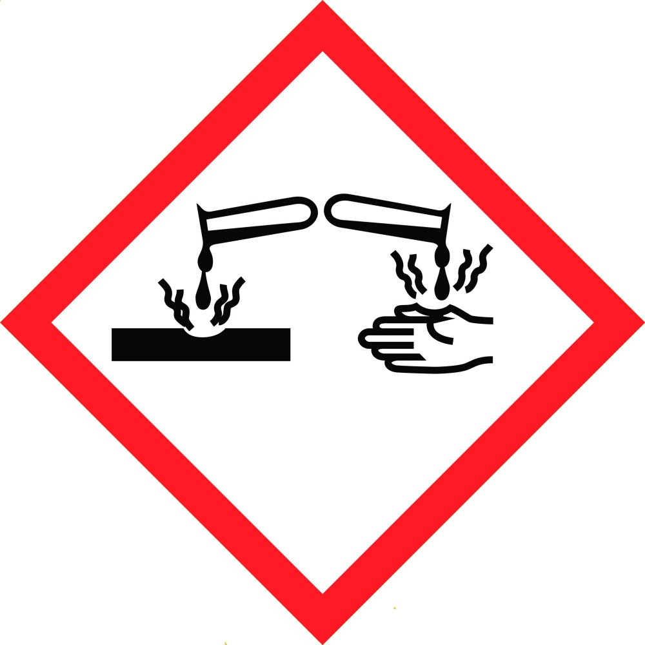 | 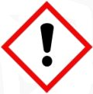
SIGNAL WORD | DANGER
Acute Toxicity Oral – Category 4
Skin corrosion – Category 1
Eye corrosion – Category 1

Hazard Statement(s)
H302 | Harmful if swallowed.
H312 | Causes severe skin burns and eye damage.
H401 | Toxic to aquatic life.

Prevention(s)
P102 | Keep out of reach of children.
P260 | Do not breathe fumes, mists, vapours or spray.
P264 | Wash contacted areas thoroughly after handling.
P270 | Do not eat, drink, or smoke when using this product.
P273 | Avoid release to the environment.
P280 | Wear protective gloves, protective clothing and eye or face protection.
Refer to the SDS before using the product

Response
P301+P312: | IF SWALLOWED: Call a POISON CENTRE or doctor if you feel unwell
P301+P330+P331 | IF SWALLOWED: Rinse mouth. Do NOT induce vomiting.
P303+P361+P353 | IF ON SKIN (or hair): Remove immediately all contaminated clothing. Rinse skin with water.
P304+P340 | IF INHALED: Remove victim to fresh air and keep at rest in a position comfortable for breathing.
P305+P351+P338 | IF IN EYES: Rinse cautiously with water for several minutes. Remove contact lenses, if present and easy to do. Continue rinsing.
P310 | Immediately call a POISON CENTRE phone Australia 131 126 or doctor/physician.
P330 | Rinse mouth.
P363 | Wash contaminated clothing before reuse.
P391 | Collect spillage.

Storage
P405 | Store locked up

Disposal
P501 | If they can not be recycled, dispose of contents to an approved waste disposal plant and containers to landfill (see Section 13 of this SDS).

- Composition/Information on Ingredients
(Listed when present at 1% or greater, carcinogens at 0.1% or greater)

Chemical Name | CAS Registry Number | % Weight | Hazard Information
Potassium hydroxide | 1310-58-3 | 10 – 30 | H290: May be corrosive to metals.  H302: Harmful if swallowed.  H314: Causes severe skin burns and eye damage.  TWA: 2 mg/m3  STEL: 2 mg/m3 “peak”
Sodium hypochlorite | 7681-52-9 | < 10 | H314 Causes severe skin burns and eye damage  H305 STOT SE3
Ingredients determined to be non-hazardous | various | 10 - 30 | None
Water | 7732-18-5 | To 100 | None
The SWA TWA exposure value is the average airborne concentration of a particular substance when calculated over a normal 8 hour working day for a 5 day working week. The STEL (Short Term Exposure Limit) is an exposure value that may be equalled (but should not be exceeded) for no longer than 15 minutes and should not be repeated more than 4 times per day. There should be at least 60 minutes between successive exposures at the STEL. The term "peak "is used when the TWA limit, because of the rapid action of the substance, should never be exceeded, even briefly.
- First Aid Measures
For Advice contact a Poisons Information Centre (phone eg. Australia 131126: New Zealand 0 800 764 766) or a Doctor.
Inhalation | If irritation occurs, contact a Poisons Information Centre, or call a doctor. Remove source of contamination or move victim to fresh air. If breathing is difficult, oxygen may be beneficial if administered by trained personnel, preferably on a doctor's advice. In severe cases, symptoms of pulmonary oedema can be delayed up to 48 hours after exposure.
Skin: | Seek urgent medical attention. Flush contaminated area with lukewarm, gently flowing water for at least 60 minutes, by the clock. DO NOT INTERRUPT FLUSHING. If necessary, keep emergency vehicle waiting (show paramedics this MSDS and take their advice). Under running water, remove contaminated clothing, shoes and leather goods (e.g. watchbands, belts). Strongly basic ingredients tend to penetrate the skin and so need longer rinsing than other substances.
Eyes | Immediately flush the contaminated eye(s) with lukewarm, gently flowing water for at least 60 minutes, by the clock, while holding the eyelid(s) open. Neutral saline solution may be used as soon as it is available. DO NOT INTERRUPT FLUSHING. If necessary, keep emergency vehicle waiting (show paramedics this MSDS and take their advice). Take care not to rinse contaminated water into the unaffected eye or onto face. Call a Poisons Information Centre or a doctor urgently. Take special care if exposed person is wearing contact lenses.
Ingestion: | If swallowed, do NOT induce vomiting; rinse mouth thoroughly with water and contact a Poisons Information Centre. Urgent hospital treatment is likely to be needed. Give activated charcoal if instructed.
First aid facilities | Ensure eyewash and safety shower facilities are available in workplace.

Advice to Doctor
Indication of any immediate medical attention and special treatment needed
For acute or short-term repeated exposures to highly alkaline materials: | Respiratory stress is uncommon but present occasionally because of soft tissue edema.  Unless endotracheal intubation can be accomplished under direct vision, cricothyroidotomy or tracheotomy may be necessary.  Oxygen is given as indicated.  The presence of shock suggests perforation and mandates an intravenous line and fluid administration.  Damage due to alkaline corrosives occurs by liquefaction necrosis whereby the saponification of fats and solubilisation of proteins allow deep penetration into the tissue.  Alkalis continue to cause damage after exposure.
Ingestion | Milk and water are the preferred diluents  No more than 2 glasses of water should be given to an adult.  more than 2 glasses of water should be given to an adult.  Neutralising agents should never be given since exothermic heat reaction may compound injury.  Catharsis and emesis are absolutely contra-indicated.  Activated charcoal does not absorb alkali.  Gastric lavage should not be used.  Supportive care involves the following:  Withhold oral feedings initially  If endoscopy confirms transmucosal injury start steroids only within the first 48 hours.  Carefully evaluate the amount of tissue necrosis before assessing the need for surgical intervention.  Patients should be instructed to seek medical attention whenever they develop difficulty in swallowing (dysphagia).
Skin And Eye | Injury should be irrigated for 20-30 minutes.  Eye injuries require saline. [Ellenhorn & Barceloux: Medical Toxicology

- Fire Fighting Measures
Extinguishing Media
Water spray or fog.
Foam.
Dry chemical powder.
BCF (where regulations permit).
Carbon dioxide.
Special hazards arising from the substrate or mixture

Fire Incompatibility | None known.
Advice for firefighters

Fire Fighting | Alert Fire Brigade and tell them location and nature of hazard.  Wear full body protective clothing with breathing apparatus.  Prevent, by any means available, spillage from entering drains or water course.  Use fire fighting procedures suitable for surrounding area.  Do not approach containers suspected to be hot.  Cool fire exposed containers with water spray from a protected location.  If safe to do so, remove containers from path of fire.  Non combustible.  Not considered a significant fire risk, however containers may burn.
Fire/Explosion Hazard | Decomposes on heating and produces toxic fumes of chlorides
- Accidental Release Measures
Minor Spills | Clean up all spills immediately.  Avoid breathing vapours and contact with skin and eyes.  Control personal contact with the substance, by using protective equipment.  Contain and absorb spill with sand, earth, inert material or vermiculite.  Wipe up.  Place in a suitable, labelled container for waste disposal.
Major Spills | Clear area of personnel and move upwind.  Alert Fire Brigade and tell them location and nature of hazard.  Wear full body protective clothing with breathing apparatus.  Prevent, by any means available, spillage from entering drains or water course.  Stop leak if safe to do so.  Contain spill with sand, earth or vermiculite.  Collect recoverable product into labelled containers for recycling.
- Precautions for handling and storage
Safe Handling: | DO NOT allow clothing wet with material to stay in contact with skin  Avoid all personal contact, including inhalation. Wear protective clothing when risk of exposure occurs.  Use in a well-ventilated area.  WARNING: To avoid violent reaction, ALWAYS add material to water and NEVER water to material.  Avoid smoking, naked lights or ignition sources.  Avoid contact with incompatible materials.  When handling, DO NOT eat, drink or smoke.
Other Information | Store in original containers.  Keep containers securely sealed.  Store in a cool, dry, well-ventilated area.  Store away from incompatible materials and foodstuff containers.  Protect containers against physical damage and check regularly for leaks.  Observe manufacturer's storage and handling recommendations contained within this MSDS.

Conditions for safe storage, including any incompatibilities
Storage: | Avoid storage of harmful substances with food.  Store out of reach of children.  Containers should be kept closed in order to minimise contamination.  Store in a cool place.  Avoid contact with incompatible substances as listed in Section 10.  Containers (and outer packaging) must bear the prescribed labeling.
Storage Incompatibilities | Segregate from strong acids  Contact with acids produces toxic fumes of chlorine
Package material incompatibilities | Not Available
- Exposure controls /personal protection
Control parameters
OCCUPATIONAL EXPOSURE LIMITS (OEL)
INGREDIENT DATA

Source | Ingredient | Material name | TWA | STEL | Peak
Australia Exposure Standards | potassium hydroxide | Potassium hydroxide | Not Available | Not Available | 2 (mg/m3)
EMERGENCY LIMITS
Ingredient | TEEL-0 | TEEL-1 | TEEL-2 | TEEL-3
potassium hydroxide | 2(ppm) | 2(ppm) | 2(ppm) | 150(ppm)
sodium hypochlorite | 0.6 / 0.075(ppm) | 2 / 0.2(ppm) | 1.5 / 50(ppm) | 500(ppm)
water | 500(ppm) | 500(ppm) | 500(ppm) | 500(ppm)
No special equipment is usually needed when occasionally handling small quantities. The following instructions are for bulk handling or where regular exposure in an occupational setting occurs without proper containment systems.
Ventilation | This product should only be used in a well ventilated area. If natural ventilation is inadequate, use of a fan is suggested.
Eye Protection | Your eyes must be completely protected from this product by splash resistant goggles with face shield. All surrounding skin areas must be covered. Emergency eye wash facilities must also be available in an area close to where this product is being used.
Skin Protection | Because of the dangerous nature of this product, make sure that all skin areas are completely covered by impermeable gloves, overalls, hair covering, apron and face shield. See below for suitable material types.
Protective Material Types | We suggest that protective clothing be made from the following materials: rubber, Viton, nitrile, butyl rubber, Barricade, neoprene, Teflon, polyethylene, PE/EVAL, Saranex, Responder.
Respirator | Usually, no respirator is necessary when using this product. However, if you have any doubts consult the Australian Standard mentioned above.  Safety deluge showers should, if practical, be provided near to where this product is being handled commercially.
- Physical and chemical properties
Appearance | Clear water like liquid
Odour: | faint chlorine odour
pH | 13.5 neat
Vapour pressure: | No data.
Vapour Density: | No data.
Boiling Point: | Approximately 100°C (for liquid concentrate)
Boiling range | No data.
Melting point | No data.
Solubility in water | Miscible
Specific Gravity: | 1.1 – 1.2 @ 25 C
Flash point | Non Flammable
Solubility limits | N/a
- Stability and Reactivity
Chemical Stability | Stable at normal temperatures and pressure.
Conditions to Avoid | ACIDS: violent reaction can occur, yielding heat and pressure which can burst an enclosed container. Attacks many reactive metals (aluminium/magnesium/zinc alloys) releasing highly flammable gas (hydrogen) which generates fire or explosion hazards. Reacts slowly with ambient air (particularly carbon dioxide) which may cause certain insoluble salts top form in solutions.
Incompatible Materials | Incompatible with amines, ammonium salts, aziridine, methanol and phenylacetonitrile. Reacts with metal salts, peroxides and reducing agents. Reacts violently with acids.
Hazardous Decomposition Products | Product can decompose on combustion to form Carbon Monoxide, Carbon Dioxide, and other possibly toxic gases and vapours on burning. Reacts vigorously with acids producing dangerous levels of gaseous chlorine.
- Toxicological information
Health effects from acute exposure
Swallowed | Corrosive. Can cause damage to throat, lungs and stomach.
Eye | Corrosive and may cause severe or permanent eye damage, Concentrated solutions can cause severe irritation and corrosion injury unless washed out immediately
Skin | Irritating to skin. Brief contact may cause redness. Repeated or prolonged contact may result in corrosion.
Inhaled | Can be irritating to the nose, throat and upper respiratory tract.
Health effects from chronic exposure | Prolonged or repeated contact may cause dermatitis. No other specific data is available for the product for chronic exposure symptoms.
Carcinogenicity | No known effect
Mutagenicity | No known effect
Teratogenicity | No known effect
- Ecological information
This product is harmful to aquatic organisms. This product will not accumulate in the soil or water or cause long term problems. However, until diluted or neutralised it will kill all aquatic organisms it contacts due to extreme pH.
- Disposal considerations
Disposal | Review federal, state and local government requirements prior to disposal.
- Transport Information
UN Number | 1814
Proper Shipping Name | Potassium Hydroxide Solution
DG Class | 8
SUBSIDARY RISK | none allocated
Packaging Group | II
Recommended Use | Detergent for machine dishwashing, food process cleaning.
- Regulatory Information
AICS | All of the significant ingredients in this formulation are compliant with NICNAS regulations.
- Other information

Abbreviations
AICS | Australian Inventory of Chemical Substances
CAS Number | Unique Chemical Abstracts Service Registry Number
EC50 | Ecotoxic Concentration 50% — concentration in water which is fatal to 50% of a test population (e.g. daphnia, fish species)
ES | Exposure Standard - The airborne concentration of a biological or chemical agent to which a worker may be exposed in a work day
GHS | Globally Harmonised System of Classification and Labelling of Chemicals
HAZCHEM Code | Emergency action code of numbers and letters that provide information to emergency services, especially fire fighters
IARC | International Agency for Research on Cancer
LEL | Lower Explosive Limit
LD50 | Lethal Dose 50% — dose which is fatal to 50% of a test population (usually rats).
LC50 | Lethal Concentration 50% — concentration in air which is fatal to 50% of a test population (usually rats)
NICNAS | National Industrial Chemicals Notification and Assessment Scheme
Peak Limitation | Peak Exposure Value: The maximum airborne concentration of a biological or chemical agent to which a worker may be exposed at any time.
SDS | Safety Data Sheet
STEL | Short Term Exposure Limit - The maximum airborne concentration of a chemical or biological agent to which a worker may be exposed in any 15 minute period, provided the TWA is not exceeded
TWA | Time Weighted Average — generally referred to ES averaged over typical work day (usually 8 hours)
UEL | Upper Explosive Limit
UN Number | United Nations Number

References
Data | Unless otherwise stated comes from IUCLID datasheet for the specific chemical.
NOHSC: 1003 | National Occupational Health and Safety Commission 1995, Exposure Standards for Adopted National Exposure Standards for Atmospheric Contaminants in the Occupational Environment [NOHSC:1003(199511
Prepared By | Jon Sprinkhuizen
Date of Issue | 1st of February 2021
Changes Made | Update SDS to GHS format
References | Australian Dangerous Goods Code Preparation of Safety Data Sheets for Hazardous Chemicals Code of Practice 2011. Standard for the Uniform Scheduling of Medicines & Poisons (SUSMP) Guidance
Contact Person/Point | Australia 24 HOUR EMERGENCY CONTACT Poisons Information Centre 13 11 26
Legal Disclaimer | The above information is believed to be correct with respect to the formula used to manufacture the product in the country of origin. As data, standards, and regulations change, and conditions of use and handling are beyond our control, NO WARRANTY, EXPRESS OR IMPLIED, IS MADE AS TO THE COMPLETENESS OR CONTINUING ACCURACY OF THIS INFORMATION.

End of SDS

